The Competence -Commitment Model
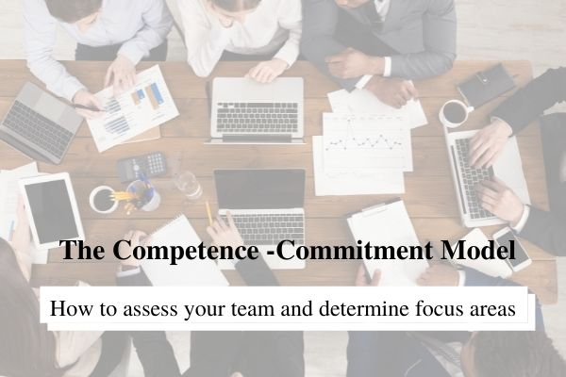

The Competence-Commitment Model

The Competence-Commitment Model, developed by Jack Welch, is a super simple tool you can use to quickly assess your team and determine where your focus needs to be.

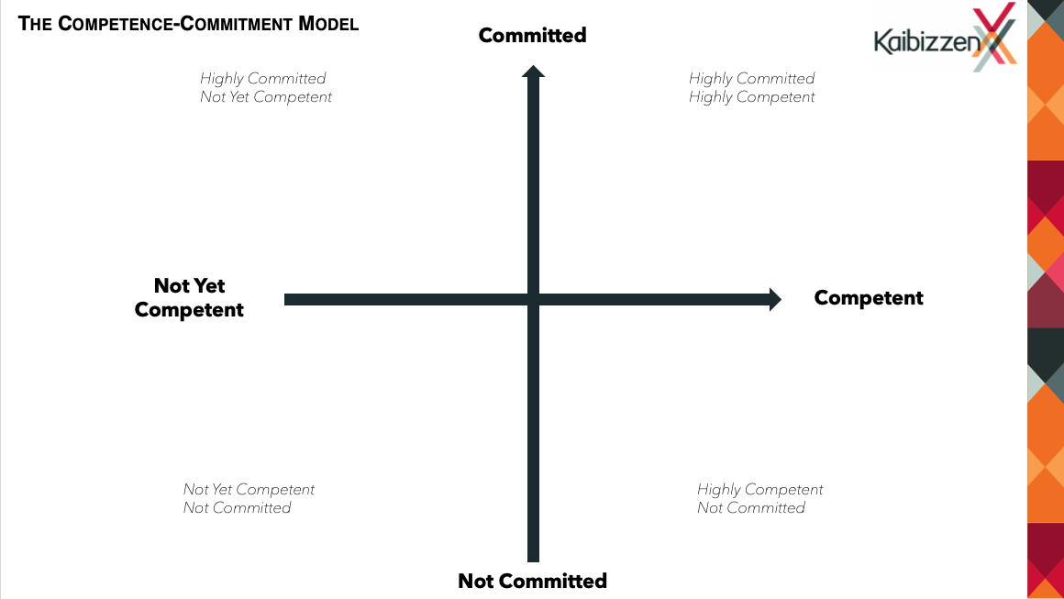

For the Competence-Commitment Model to work effectively, you must follow this process.

Step 1. Define what you mean when you say someone is ‘competent’ in their role.

Step 2. Describe what it looks like when someone is ‘competent’ in their role. What are the behaviours you’d expect to see from someone who is competent?

Step 3. Describe what it looks like when someone is ‘not yet competent’ in their role. What are the specific behaviours you’d expect to see from someone who is not yet competent?

Step 4. Define what you mean when you say someone is ‘committed’ to your business.

Step 5. Describe what it looks like when someone is ‘committed’ to your business. What are the behaviours you’d expect to see from someone who is committed?

Step 6. Describe what it looks like when someone is ‘not committed’ to your business. What are the specific behaviours you’d expect to see from someone who is not committed?

Step 7. Assess each employee individually based on your definitions of ‘competent’ and ‘committed’ and plot them accordingly. You can download a copy of ‘The Competence-Commitment Model’ here.

What to do with employees in the different quadrants

Competent and committed employees

Keep them! These are your stars. They are both good at what they do and are committed to the business achieving its objectives. Typically, these are the 20 per cent of your workforce who are responsible for 80 per cent of the results. Ultimately, you want all your employees to be in this quadrant.

Not yet competent and not committed

You need to move these people on. Because they are not committed to your business, no amount of training will improve their performance. These people are unsuited for the role they’re in, do not believe in your vision for the business and really don’t want to be there.

Moving these people on is in everyone’s best interest. In our experience, when we’ve let these people go, they often come back to us a few years later and thank us. Being let go was the kick in the pants they needed to go and find what they really wanted to do.

Not yet competent, but committed

These team members are committed to your business but aren’t yet competent in their roles.

For these people, appropriate training is usually all that’s required to move them into the competent-committed quadrant. To do this, co-create with them a development plan which steps out where they need to upskill and identifies clear timeframes for completion and review.

Competent, but not committed

They can be, without question, the most dangerous people in your employment.

Because these people are good at what they do, your employees who are not as competent often look to them for guidance. This means their non-committed attitude can spread like wildfire through your organisation and therefore regarded as toxic employees.

Additionally, you can lose your best employees because of this group. When your star performers consistently find themselves picking up the slack for these people – and you as the leader consistently do nothing to address it – they walk.

With this group, your first step is to find out what’s causing the non-commitment. Typically, this is done through a directed but non-confrontational conversation.

Then you’ll need to put a performance Improvement plan in place. This plan will clearly identify all areas for improvement with timeframes for review. If, at the end of the plan there is minimal or no change in the employee, you must move them on immediately.

By implementing this simple tool in your business, you’ll know exactly what you need to do to create an entire team of star employees. These high-performing, highly engaged teams are, on average, 21 per cent more profitable and require far less work on the part of the owner to lead them.

At Kaibizzen we offer one on one business coaching to ensure you get the individualised support you need. If you would like to know more about how we could partner with your business to create a team of star employees, contact us for a confidential discussion. We’d love to work alongside you to achieve the business you deserve for you and your family through our life business coaching services.

